Chapter 8 notes

Business Cycles
Market economies experience fluctuations in real GDP and employment over time. These fluctuations are referred to as the business cycle. A recession is said to occur when real GDP falls (typically economists will only say that a recession has occurred if real GDP has fallen for two consecutive quarters). An expansion occurs when output is rising. The graph below depicts the stages of a simple business cycle. The peak of the cycle is the point at which an expansion ends and a recession begins. A recession ends and an expansion begins at the trough of the business cycle. A very severe recession has, since the experience of the 1930s, been called a depression.
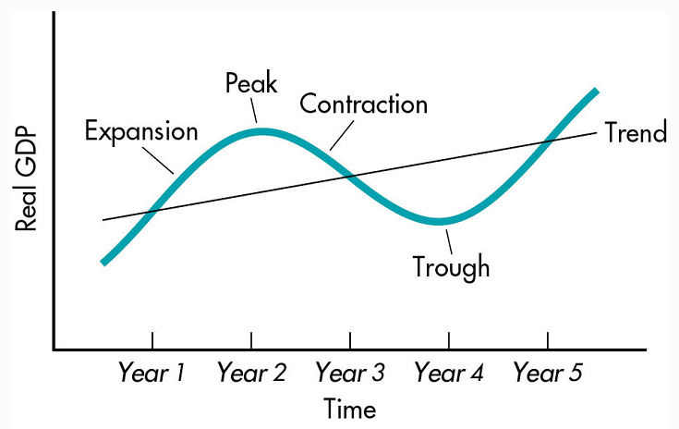
The graph below depicts U.S. real GDP from 1960 through early 2005. The shaded areas represent recessions. As this graph indicates, expansions are, on average, longer than contractions. In recent decades, recessions have become less frequent and relatively shorter. The expansions in the 1980s and the 1990s are the two longest recorded expansions.
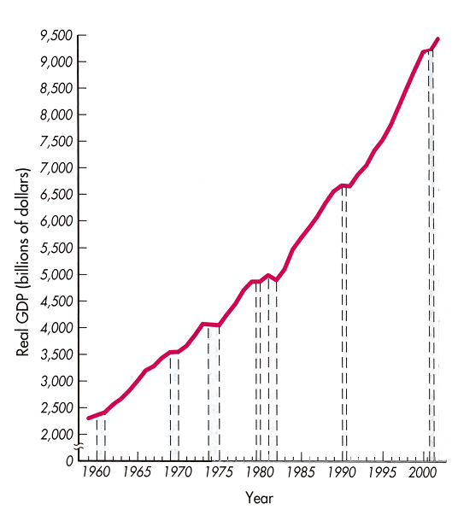
The National Bureau of Economic Research (NBER) provides official starting and ending dates of recessions.

Leading, Coincident, and Lagging Indicators
One problem with relying on GDP data to determine the current stage of the business cycle is that GDP is measured only quarterly and it takes some time to generate reliable estimates of quarterly GDP. Furthermore, policymakers would prefer to be able to forecast changes in GDP before they occur. To provide current information on the status of the business cycle and to help forecast changes in output, the U.S. Department of Commerce collects and publishes data on a collection of variables that are readily observed and have a fairly stable relationship to the level of real GDP. These variables are classified as:
- leading indicators,
- lagging indicators, and
- coincident indicators.
Leading indicators consist of a set of variables that tend to change prior to changes in real GDP. When the index of leading indicators rises, GDP generally rises in the near future. A decline in the index of leading indicators has preceded each recession during the post-WW II era (roughly half of the time, though, a downturn in the leading indicators occurs without a subsequent decline in real GDP).
Coincident indicators tend to change at the same time as GDP. Lagging indicators tend to change after GDP has changed. These are both used to help provide more evidence that a recession has begun or ended. If, for example, the leading indicators turn up one month, the coincident indicators begin to rise the following month, and the lagging indicators start rising shortly thereafter, this is is compelling evidence that an economic expansion is underway.

Labor force and unemployment
The labor force consists of all noninstitutionalized individuals aged 16 or above who are either working or actively seeking work. Those who choose to be full-time students, or retire, or withdraw from the labor force for child-rearing purposes, or who give up looking for work are not counted as part of the labor force
Individuals are unemployed only if they are not working for pay at any job and are actively seeking work.
The unemployment rate is defined as:
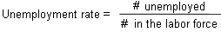
The unemployment rate generally rises during recessions and falls during periods of economic expansions. It is interesting to note, though, that when unemployed workers become discouraged and leave the labor force (these workers are called discouraged workers), the measured unemployment rate declines. (To see this, observe that while both the numerator and the denominator in the equation above decline, the ratio declines because the numerator falls by a larger percentage.) Thus, the unemployment rate may decline when the number of discouraged workers rises. Similarly, the observed unemployment rate may increase when discouraged workers become more optimistic about the state of the economy and start looking for work.
Thus, to measure the state of the labor market, it is important to examine movements into and out of the labor force as well as changes in the unemployment rate. A convenient measure of this is provided by the labor force participation rate, defined as:
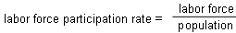
Typically, the labor force participation rate increases during periods of economic expansion and declines during periods of recession. Note that the changes that occur in the labor force participation rate over the course of the business cycle tend to dampen the fluctuations that occur in the unemployment rate. To see this, note that during a recession, unemployment rises. But because some workers become discouraged, unemployment does not rise by as much as it would if the labor force participation rate were constant. Similarly, during an expansion, unemployment rates decline, but the decline is smaller due to the increase in the labor force participation rate that generally occurs during an expansion.
The Bureau of Labor Statistics (BLS) collects and reports unemployment and labor force participation rate data for a wide variety of subgroups of the population, sorted by age, gender, marital status, and race. Data on these variables may be found at the BLS website.
Be careful to not confuse the unemployment rate with the number of people eligible to receive unemployment compensation. While all of those who receive unemployment compensation are legally required to be unemployed, a worker could be unemployed but not eligible to receive unemployment compensation (since eligibility is not available to those who voluntarily quit their job or who have not worked for a long enough time period prior to being laid off).

The Measured Unemployment Rate and the Societal Cost of Unemployment
The presence of discouraged workers causes the measured unemployment rate to understate the social cost of unemployment. The presence of underemployment also causes the unemployment rate to understate the problem of unemployment since underemployed workers are counted as being employed (even if they are only working part time and would prefer to work full time).
On the other hand, the presence of the underground economy may cause the measured unemployment rate to overstate the social costs associated with unemployment. Individuals who are working off the books are not likely to report that they are working when they are interviewed by a representative of the Bureau of Labor Statistics.

Types of Unemployment
Economists define 4 different types of unemployment:
- seasonal unemployment,
- frictional unemployment,
- structural unemployment, and
- cyclical unemployment.
Workers in industries that exhibit seasonal variations in the demand for labor experience seasonal unemployment during those periods in which labor demand is relatively low. Elementary and secondary school teachers and school crossing guards are often seasonally unemployed during the summer months. Farm workers often experience seasonal unemployment during the winter. In areas with colder climates, construction workers are often seasonally unemployed during the winter months. An individual who works only as a department store Santa Claus might expect to be seasonally unemployed for most of the year. Since workers who choose these occupations know that they will typically be unemployed for part of each year, this type of unemployment is generally considered to be a form of voluntary unemployment.
Frictional unemployment occurs when workers are engaged in voluntary job search. For this reason, it is sometimes referred to as "search unemployment." Workers searching for their first jobs or who have quit their jobs to try to find a better one are considered to be frictionally unemployed. This type of unemployment is also considered to be a form of voluntary unemployment since workers choose to engage in job search rather than accepting the first job that they find to be available. (An accountant looking for a new job is unlikely, for example, to accept an offer from a fast-food restaurant that is currently hiring.)
Some workers lose their jobs because technological change or changes in the demand for final output reduce the demand for a particular type of labor. This type of unemployment is referred to as structural unemployment. For example, the introduction of the automobile reduced the demand for blacksmiths that produced horse shoes. Similarly, the automation of many assembly processes reduced the demand for many types of labor used in production processes. The demand for bassoon players declined with the decline in the demand for classical and big-band jazz music. Changing technology and changing tastes will always render some types of labor obsolete (while increasing the demand for other types of labor). Even though there may be many job openings in an economy, structural unemployment will persist since the job skills of those who lost their jobs will not necessarily match the skills required in the new jobs that are open.
People who lose their jobs because the economy enters a recession are said to experience cyclical unemployment. One of the main objectives of macroeconomic policy is to keep the level of cyclical unemployment as close to zero as possible.

Costs of unemployment
One of the major costs of unemployment is the GDP gap, defined as:
GDP gap = potential real GDP - actual real GDP
Potential GDP is defined to be the level of GDP that would occur if there were no cyclical unemployment. An alternative way of stating this is to say that the economy is at potential GDP when the level of unemployment equals the natural rate of unemployment. The natural rate of unemployment is defined as the unemployment rate that would exist if there is no cyclical unemployment. In other words, at the natural rate of unemployment, all unemployment is seasonal, frictional, or structural. (Note that workers who are unemployed when the economy is at the natural rate are either voluntarily unemployed or have become unemployed because of changes in the composition of labor demand, not because of macroeconomic problems.) Since frictional, seasonal, and structural unemployment can vary with the rate of technological change, the age structure of the population, and similar factors, the natural rate of unemployment will vary over time. Most economists suggest that, in recent years, the natural rate of unemployment is somewhere between 4% and 5%. In the 1970s and 1980s, it was believed that it was between 6% and 7%. (Since there were many new workers entering the labor force at this time, frictional unemployment was relatively high. The shift from an industrial to a service economy also increased structural unemployment).
Other costs of unemployment include psychological costs for unemployed workers and their families. These costs often are often experienced by society in the form of increases in suicide rates, alcohol abuse, and crime when the unemployment rate rises.

The Record of Unemployment
Different demographic groups have experienced quite different unemployment rates. Until recently, women had higher unemployment rates than males. Teenagers and new workers have the highest unemployment rates for any age group. Nonwhites have experienced higher unemployment rates.
U.S. unemployment rates have generally been lower than those in the industrialized economies of Europe.

Inflation
Inflation is said to occur when there is a sustained increase in the average level of prices. The inflation rate is usually measured as the year-to-year percentage change in a price index (such as the CPI or GDP Price Index). As the price level rises, the purchasing power of a dollar declines.

Costs of inflation

Anticipated Inflation
If inflation is anticipated, wage and other resource contracts will take the expected effect of inflation into account. If wages and other resource prices take inflation into account, the real wage will not change (unless there is a shift in either labor demand or labor supply). Firms that expect a 5% increase in the price of their product in the next year will be willing to pay workers 5% more next year. Similarly, workers will require a 5% pay increase to provide the same quantity of labor when there is 5% inflation. If everyone anticipates this inflation, real incomes will remain unchanged and everyone will be able to buy the same amount of real output. If everything costs 5% more, but everyone's income increased by 5%, it appears at first glance that everyone will be able to maintain the same level of real income.
There are, though, some real costs associated with a higher inflation rate even if it is fully anticipated. One of these is the higher level of information and transaction costs that occur when prices change more often. If prices are changing frequently, new lists of prices must be printed and or otherwise disseminated. Buyers of goods must devote more time and effort to acquiring information on current prices. These additional costs require the use of resources that could be otherwise devoted to producing more output.
Still another cost of inflation is something that was referred to by James Tobin as the "shoe-leather cost" of inflation. While most prices can adjust to anticipated inflation, assets that are denominated in dollars lose value at a faster rate when the inflation rate rises. In response, individuals and firms will choose to hold more of their wealth in the form of interest-bearing assets and less in the form of currency and checkable deposits. This leads to increased financial transactions. These transactions take time and effort that could have been devoted to other productive tasks. (The term "shoe-leather cost" came from the suggestion that people would wear out their shoes more rapidly by the extra trips to their banks.)

Unanticipated Inflation
If inflation is not anticipated by some or all participants in the economy, the costs of inflation will include an arbitrary redistribution of income and wealth, in addition to the costs listed above. Individuals whose incomes do not keep up with inflation will lose income and wealth relative to those whose nominal income grows at a faster rate. Individuals receiving fixed incomes (such as individuals receiving fixed-payment pension plans) receive an unexpected decline in their real income.
One of the ways in which income adjusts to changes in inflation is through changes in nominal interest rates. The nominal interest rate is expressed in current dollars. Individuals, though, are assumed to make decision on borrowing or lending based upon the expected real interest rate. The real interest rate is a measure of the real cost of borrowing. The real interest rate may be expressed as: <blockquote<="" blockquote="">An example should help to illustrate this relationship. Suppose that you loan a friend $100 for a year when 5% inflation is expected. If you only want to get back the same value of money that you loaned, you would have to receive $105 next year to have the same purchasing power as $100 provides today. Thus, you would receive a 0% real return when you loan money at a 5% interest rate when there is 5% inflation. If you wished to receive a 2% real return on your loan, you would have to charge a 7% nominal interest rate when 5% inflation is anticipated. Nominal interest rates are expected to rise by 1% when expected inflation rises by 1%.</blockquote
If realized inflation differs from nominal inflation, though, the realized real interest rate will differ from the real interest rate that was anticipated when the loan was made. If the realized inflation rate exceeds the inflation rate anticipated at the time a loan is made, the loan is paid back in dollars that are worth less than anticipated. This benefits the debtor at the expense of the creditor. If, on the other hand, realized inflation is less than anticipated, creditors gain at the expense of debtors.
The relationship between nominal and real interest rates was a major source of disagreement between Thomas Jefferson and Alexander Hamilton in early U.S. history. Jefferson, as an advocate of farmers (who tend to be debtors), was opposed to a central bank that would restrain inflation. Hamilton, as an advocate of the bankers and industrialists (who tended to be creditors), advocated a strong central bank that would keep inflation at a low rate. This issue returned many times over the course of U.S. history. William Jennings Bryan's famous "Cross of Gold" speech advocated the use of silver as well as gold to back the U.S. money supply. Bryan represented farmers who would benefit from the unanticipated inflation that would occur in response to the resultant increase in the money supply.

Types of Inflation
Economists generally classify inflation into three types (your text lists two, but the third is just a combination of these):
- demand-pull inflation,
- cost-push inflation, and
- structural inflation (also known as the "wage-price spiral").
Demand-pull inflation is cased by an increase in the demand for output. The U.S. experienced demand-pull inflation during wartime, during World Wars I and II, immediately after World War II (as a result of the pent-up demand that had built up during the rationing that accompanied WW II), and during the 1960s (due to both the Vietnam War and the War on Poverty).
Cost-push inflation occurs as a result of increases in production costs. The inflation that resulted from rising energy prices during the 1970s, the early 1980s, and during the past few years are examples of cost-push inflation.
Structural inflation occurs when demand-pull or cost-push inflation results in the creation of inflationary expectations that become self-fulfilling prophecies. Once everyone expects 5% inflation, higher prices lead to higher wages and higher wages lead to higher prices. Workers who face higher prices demand higher wages. Firms that have to raise wages will raise their prices. When this occurs, an initial increase in inflation can lead to a continuous upward spiral in resource prices and output prices.

Hyperinflation
At times, countries that experience an extremely high rate of inflation, referred to as hyperinflation. This occurred in Germany during the Weimar Republic between 1924 and 1926. (This hyperinflation helped to set the stage for the rise of the Nazi party in Germany.) Several South and Central American countries have experienced hyperinflation in recent decades. At some point, the old currency effectively becomes worthless and is replaced by a new currency. As we will see later in this course, these periods of hyperinflation have been caused by rapid growth in the money supply. (The hyperinflation in Germany was caused in large part by the large reparation payments demanded after World War I. This had been predicted at the time of the Versailles treaty by John Maynard Keynes in his first famous work, The Economic Consequences of the Peace.)

